Division(s): N/A

ITEM PF7E

PENSION FUND COMMITTEE – 13 DECEMBER 2007

OVERVIEW AND OUTLOOK FOR INVESTMENT MARKETS

Report by the Independent Financial Adviser

- The impact of the ‘credit crunch’, which originated from the sub-prime problem in the USA, on economic growth is still hard to evaluate. Banks in the western world are not just hesitant to lend to each other in the money markets, because they do not know who in the market are holding securitised sub-prime loans in CDOs (collateralised debt obligations), but they are also tightening lending standards to both retail borrowers and corporate customers. As a result consensus estimates of economic growth, particularly for the half of next year, are still probably too high having been only trimmed slightly from before the credit crisis began.

Consensus Forecasts  Of GDP growth | 2006 | 2007 | 2008 | 2009
UK | 2.8 | 2.9 | 2.0 | 2.5
USA | 2.9 | 2.0 | 2.4 | 2.8
EUROZONE | 2.9 | 2.6 | 2.0 | 2.0
JAPAN | 2.2 | 2.0 | 1.9 | 1.8

- In the UK the housing market is cooling rapidly, with mortgage approvals sharply down and with expectations that house prices will be flat at best if not decline. In some areas, particularly in ones of over supply, prices of flats have already fallen meaningfully. The worsening outlook for housing, together with the squeeze on real disposable income through rising taxes and higher inflation, plus tightening borrowing standards and those with two year mortgages fixed at low rates in 2005 now re-mortgaging at much higher rates, is beginning to impact retail sales and consumer expenditure generally. The manufacturing and service sectors are also slowing. Providing the US economy does not worsen seriously the UK should avoid a recession (defined as two quarters of negative growth). In the USA the housing market continues to deteriorate as the following charts show.

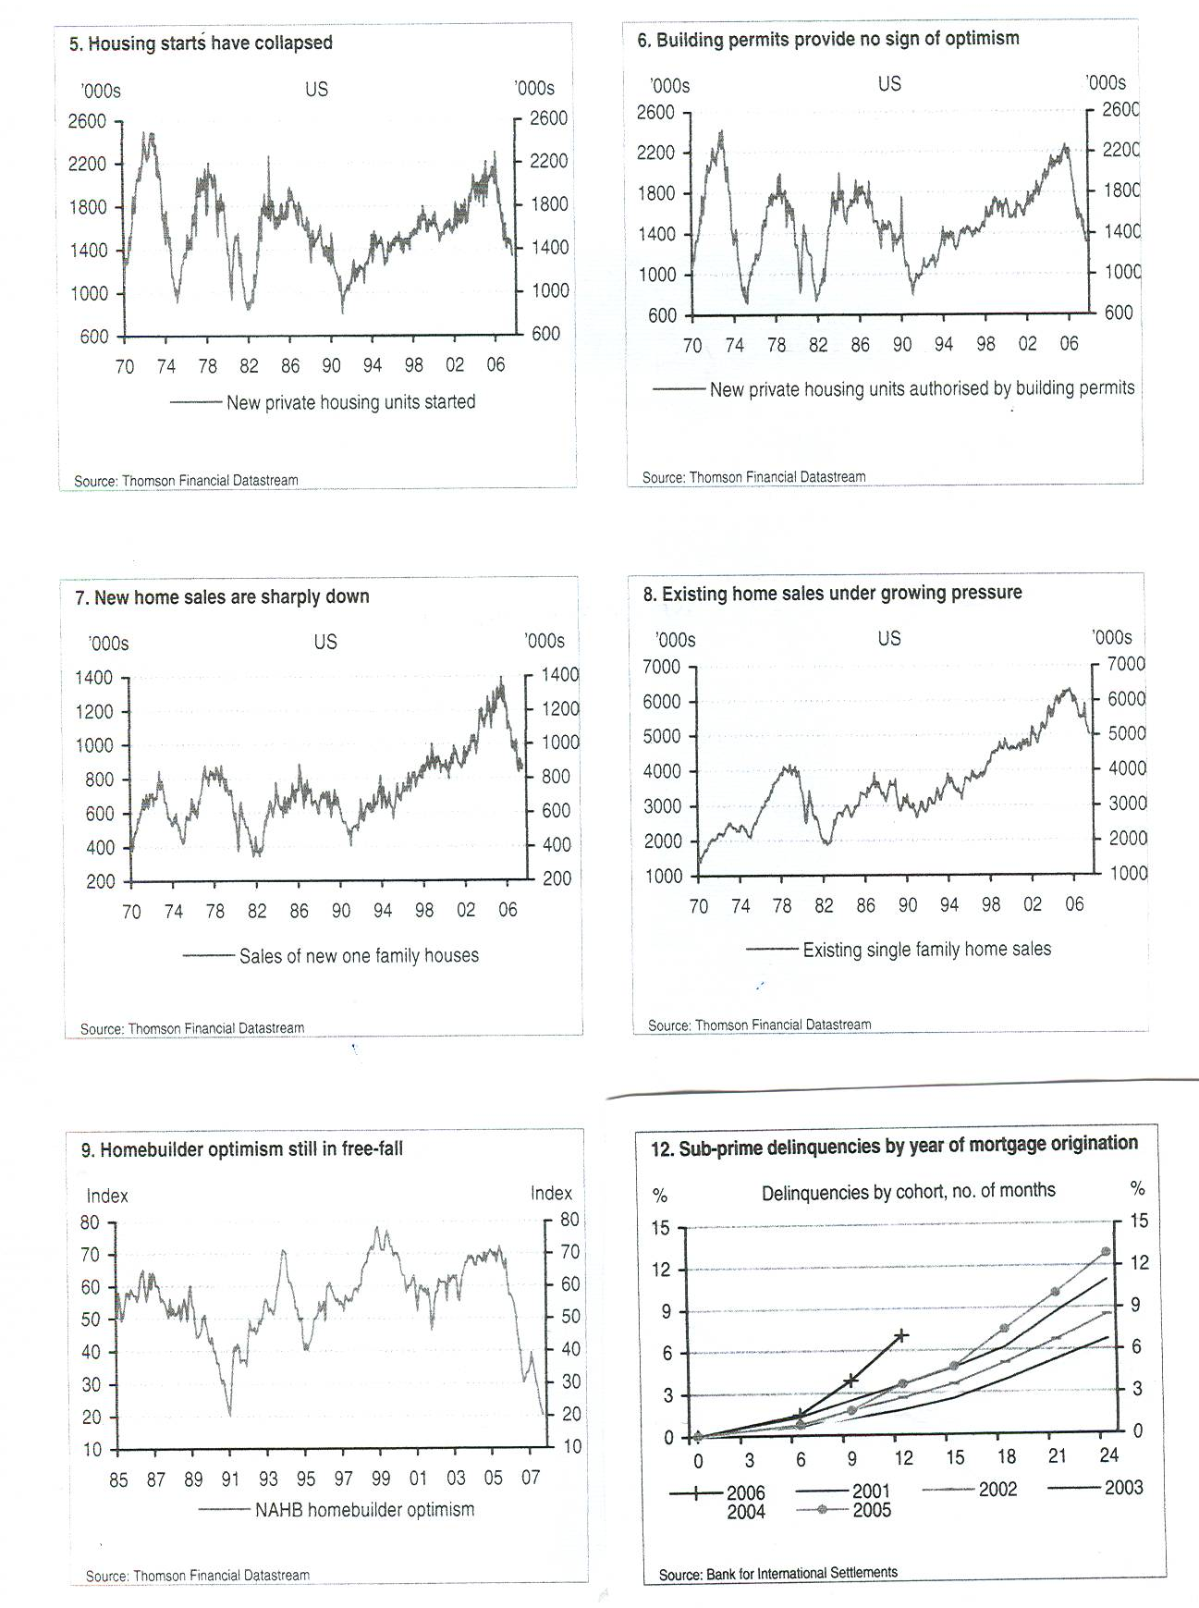

- House builder optimism has sunk to the level of 1990 and sub-prime delinquencies are rising sharply. So far employment generally is holding up, but the economy is slowing and consumer spending is likely to be subdued. Consumer confidence has fallen sharply and the Institute of Supply Management’s index of economic activity has fallen from 52.0 to 50.9, 50 being the level dividing expansion from contraction. Euro zone economic growth has peaked, and while exports continue to hold up in spite of the strong euro, domestically generated growth will slow. While in Japan the index of leading economic indicators hit zero in September, the first time in a decade, indicating that growth is stumbling. In the developing world (BRIC - Brazil, Russia, India and China) economic growth continues at a rapid pace, but reduction in demand by developed countries for their exports would have an impact and so they cannot de-couple entirely from the fortunes of the west.

- Inflationary pressures are rising, with oil being a principal factor. Unlike in 1973 when the price was driven by supply constraints by OPEC, this time the price is driven by demand, particularly from developing countries such as China and India. So far global economic activity has not been constrained by it, but the longer the price remains elevated, particularly nudging the US$100 level, the more likely there is also to be a negative impact on economic growth. Speculation, coupled with geo-political fears and declining inventories, have helped to drive the price, but if economic growth in the developed world softens this would reduce the pressure on prices and speculators might then unwind, bringing the price back further. The rise in food prices, again driven by increasing demand from developing countries as living standards rise, have added to inflationary pressures.

- As a result central banks are caught in a dilemma, with inflationary pressures rising, but economic growth weakening, the extent to which is as yet unclear. In July, before the ‘credit crunch’ nearly all central banks were looking to increase interest rates to counter inflationary pressures. Now every where rates have clearly peaked and are headed downwards in spite of inflationary pressures having increased in the short to medium term. In the USA the Fed. Funds rate has been reduced from 5¹/₄% to 4¹/₂% and the market is looking for it to fall to 4% in the first half of next year in the face of weakening growth. While the Bank of England has the remit to target inflation on the CPI of 2%, recent pronouncements have focused on the risks of economic slow down and the need to respond, implying lower rates. The Bank’s current ‘repo’ rate of 5³/₄% could easily be down to 5¹/₄% in the first half of the year. In the Euro zone inflation is currently 2.6% and heading higher, against the European Central Bank’s target of ‘below but close to 2%’. Nevertheless the ECB rate has clearly peaked and could be cut in the not too distant future. With the economy faltering in Japan, the Bank of Japan’s rate of ¹/₂% is clearly on hold. However the ‘credit crunch’ in western money markets, with banks reluctant to lend to each other, has meant that market rates have been well above central bank rates. Thus, in London the 3 month LIBOR rate, which is a benchmark rate, has ranged up to 6³/₄% against the Bank of England’s own rate of 5³/₄%. This situation could well continue until the middle of 2008, when hopefully the full extent of the US sub-prime damage on banks and other financial institution’s balance sheets will be known. In the meantime, these higher market rates will inevitably increase the cost of borrowing for corporate clients and negatively impact business investment.

Markets

- The UK equity market as measured by the FTSE 100 index fell 12.8% from a high this year of 6716 on 13 July, just before the ‘credit crunch’ broke, to a low of 5858 on 16 August. It then recovered to 6677 on 18 October and has since fallen back in highly volatile conditions to 6180. So the question remains, is the recovery from the August low, in market terminology, just a ‘dead cat bounce’, or is the market consolidating to move ahead next year. There are substantial reasons on the negative side. The business cycle is mature and profits as a percentage of GDP are near or at record levels in most western markets. The bull market in the UK is over 4¹/₂ years old and in the US just over 5 years old. Since 1942 the average length of bull markets in the US is just over 4¹/₂ years, while the longest up to 2000 was 9¹/₂ years. The same pattern occurred in the UK. Liquidity in the market is now much lower, with the sharp decline in cash take overs and the reduction in share buy backs and now the ‘credit crunch’, is encouraging a flight to the safety of government securities, while the market waits to see the extent of the damage of sub-prime defaults on bank and other financial institutions balance sheets and the impact the ‘crunch’ will have on the real economy and economic growth.
- On the positive side, the sub prime problem initially only impacts a part of one sector in the economy, and is much less of a problem in the UK. Importantly employment is holding up, company balance sheets are very strong, including the banks who have enormous reserves in relation to probable sub-prime defaults. It is true that the ‘credit crunch’ in the USA in 1990 when the aftermath of collapse of the leveraged bond market which left one investment bank bankrupt and the re-regulation of housing finance did lead to a bear market in the USA, while high inflation, very high interest rates and a housing crash in the UK caused a similar bear market, and in both markets balance sheets were not strong. So conditions then are not precisely mirrored today. Moreover, profits have in recent years grown faster than share prices have risen, so the price earnings ratio has declined to a more reasonable level as the charts below of the US market show.

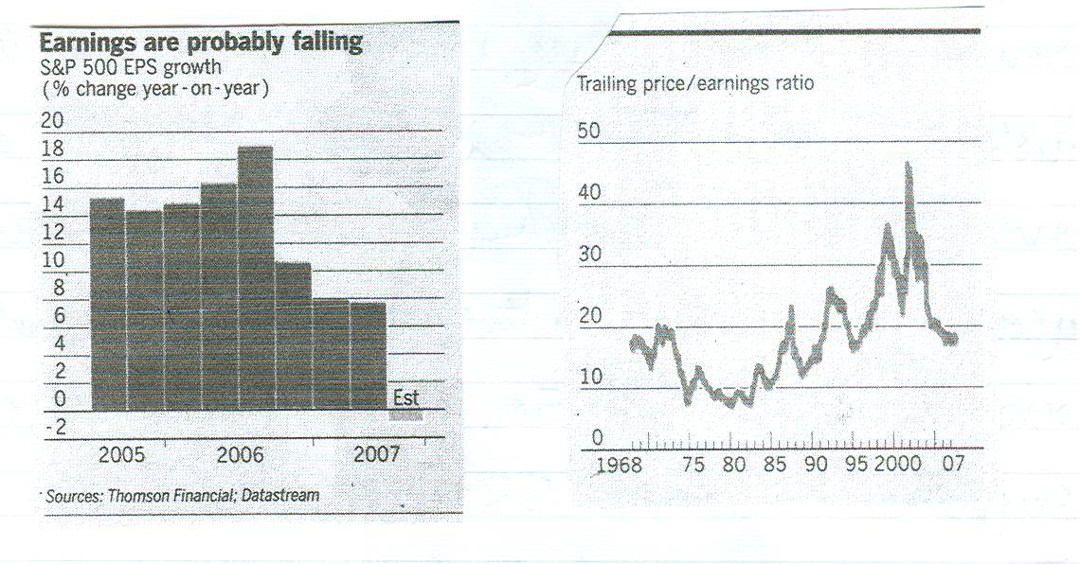

- Company earnings (profits) may well be negative in the western world during this last quarter of the year, dragged down by the substantial bank write-downs for sub-prime, but for 2007 as whole profits should be modestly up and if some economic growth is maintained in 2008, there should be a further increase in profits (company earnings). Price earnings ratios for 2008 for the UK are projected at around 12¹/₂ X, for the USA 14¹/₂X (20 year average 16¹/₂) and for Europe 12x, all of which are reasonable.

- The end of the year in the money market is going to be difficult, as banks strive to balance their books, but are reluctant to lend to each other, even though the central banks stand ready to supply liquidity. Consequently the equity market will continue to be very volatile (the Vix volatility index is currently at 29, compared with a 3 year average of 15 and being as low as 10 earlier this year). The market in the UK has technical support at around FTSE 5850; if this fails the next support is around 5300.

- The emerging markets have recovered even more strongly from the August low, having risen nearly 40%. Price earnings ratios are level or even above those in developed markets, but are supported by very strong profit growth. They should be relatively less affected by problems in western markets.

- With the ‘flight to quality’ in the ‘credit crunch’ government bond prices have been bid up and so yields have fallen as the following figures show:

 | Sept 2005 | Nov 2006 | June 2007 | Aug 2007 | Nov 2007
UK gilts – 10 years  Benchmark | 4.3% | 4.7% | 5.5% | 5.0% | 4.6%

- In June 2007 prior to the crunch gilts were sold, so yields rose, on fears of higher inflation; now with the flight to qualify they have fallen. Traditionally in these circumstances, lower yields would signal recession, but probably the current desire for security is this time the dominant factor. However, if recession is not anticipated, yields after adjusting for inflation (RPI of around 3.5%) are far too low. The same applies to index-linked yields and UK index linked yields compare unfavourably to those in other countries as the following figures show. (The real yield on bonds, after adjusting for inflation, has historically been 2% - 2¹/₂%).

Index Linked Maturities | 10 years | 30 years | 50 years
UK | 1.4% | 0.9% | 0.8%
USA | 1.6% | 1.8% | -
France | 1.8% | 2.1% | -

- The ‘credit crunch’ has resulted in risk being priced back into corporate debt. In recent years the average yield spread (i.e. increase in yield) of corporate bonds over gilts had fallen to 0.6%, but it has now risen to nearly 1.4%, around the level in year 2000, as the following chart shows.

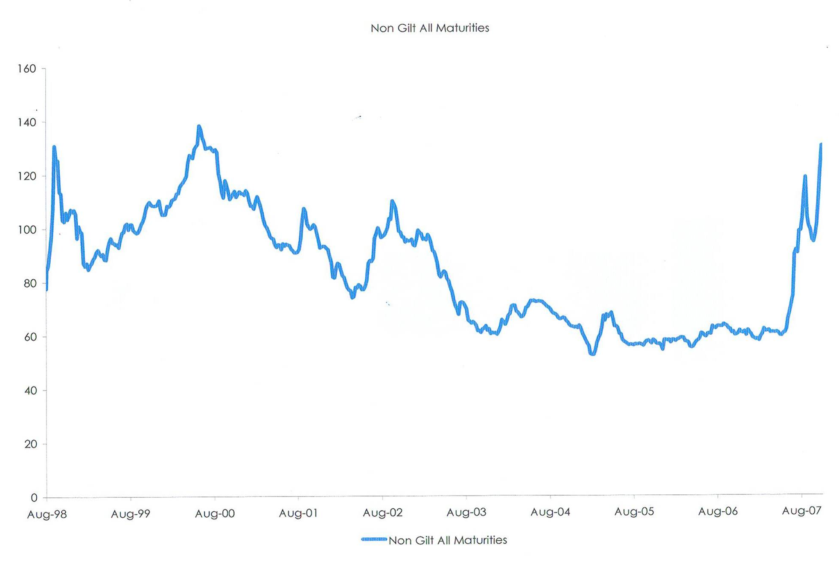

- Currencies have also been realigned in the ‘credit crunch’. The US dollar has fallen sharply. Against sterling it is $2.07 against $2.00, but the sharpest moves have been against the Euro from $1.35 to $1.49 and against the Japanese yen from yen 123 to yen 107. With the huge balance of payments deficit it is difficult to see the US$ not continuing to decline, although there will be short term rallies. Sterling is equally vulnerable on its balance of payments and medium term could fall, including against the US$.

A. F. BUSHELL

Independent Financial Adviser

November 2007

